Download/Setup:
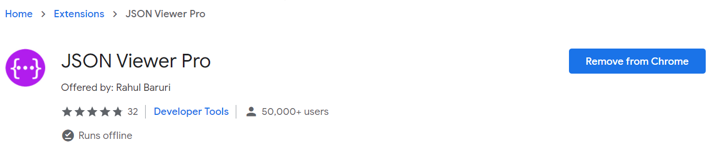
https://chrome.google.com/webstore/detail/json-viewer-pro/eifflpmocdbdmepbjaopkkhbfmdgijcc/related
To view API responses after requested.

API (Application Programming Interface)
Is a set of commands, functions, protocols, and objects that programmers can use to create software or interact with an external system.

Endpoints
Every API that interacts with an external system (server) will have an endpoint.
An endpoint is an access point to send the HTTP requests to and get your response.
The starting URL.

Paths
Can be used to narrow down on a specific piece of data you want from the external server.

Parameters
Can be used to narrow down on a specific piece of data you want from the external server.
Parameters are when a specific/custom request is sent to the external server that was unplanned or unforeseen.
Parameters starts after a question mark (?) followed by a key (contains) paired (=) with a value pair (searched word).

Authentication
Every time there’s a request through the API, the external server has to identify you as a developer and have to keep track of how often you use their server to get data. Then they’ll charge you correspondingly.

Example1:
[API JOKE Website] https://sv443.net/jokeapi/v2/
Endpoint: https://v2.jokeapi.dev/joke/[Category/-ies] Will have an error due to lack of paths/parameters.
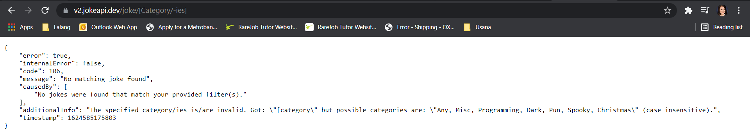

Example2:
https://v2.jokeapi.dev/joke/Programming,Spooky
Endpoint: https://v2.jokeapi.dev/joke/
Path: Programming,Spooky
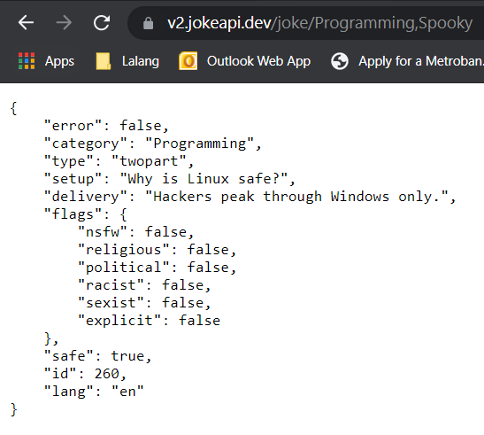

Example3:
https://v2.jokeapi.dev/joke/Programming,Spooky?contains=debugging
Endpoint: https://v2.jokeapi.dev/joke/
Path: Programming,Spooky
Parameters:?contains=debugging
Parameters starts after a question mark (?) followed by a key (contains) paired (=) with a value pair (searched word).

API Actual Samples:
OpenWeatherMap: https://openweathermap.org/api
Postman API Platform: https://www.postman.com/downloads/
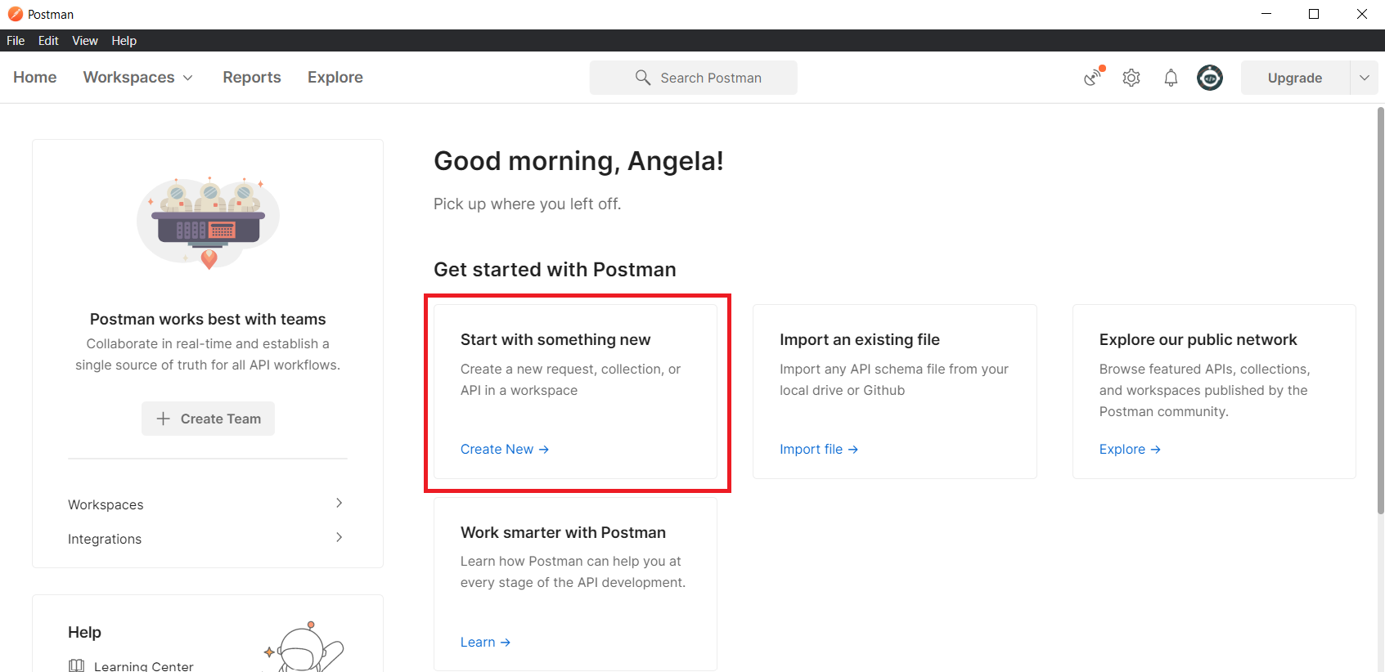
Start off by adding the endpoint of your API.
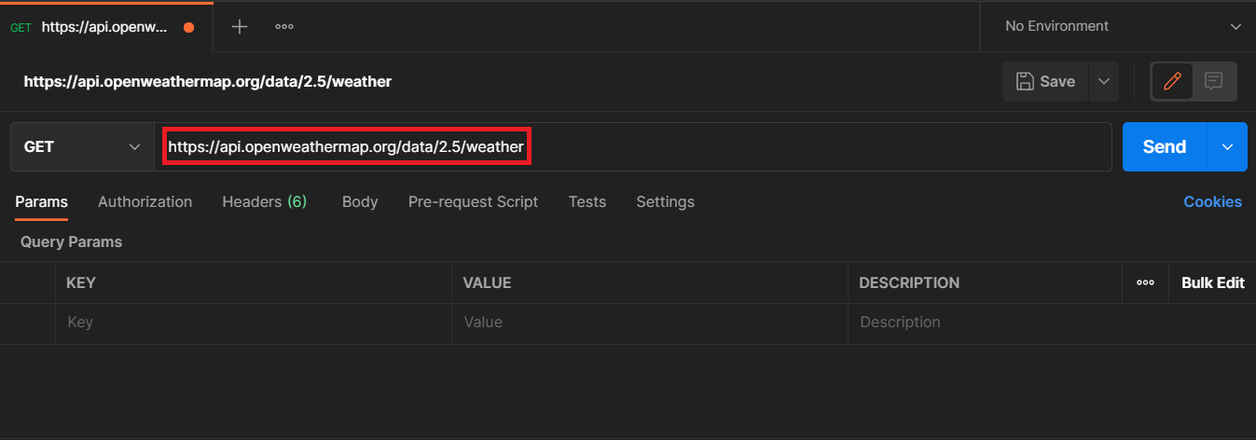
Then add the corresponding parameters:
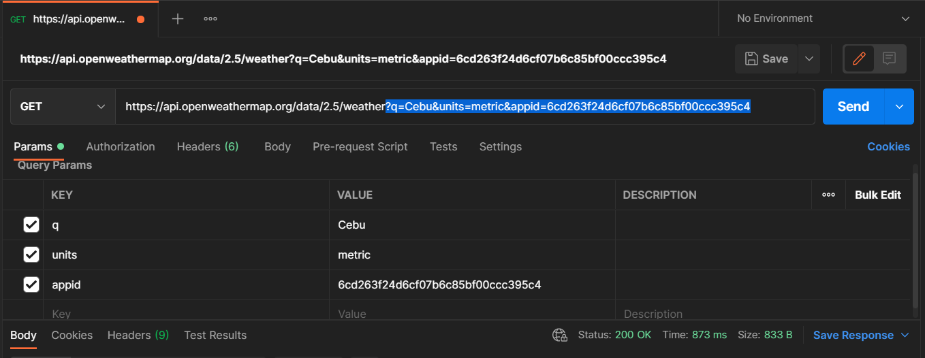
Send the HTTP Request:
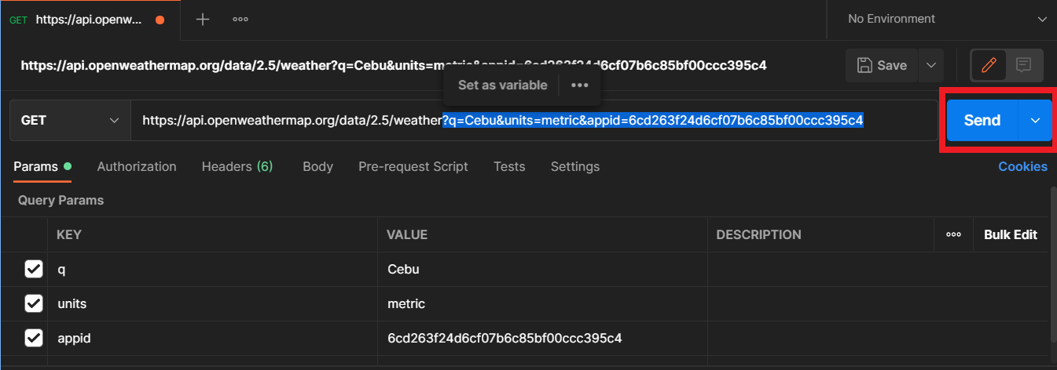
Result:
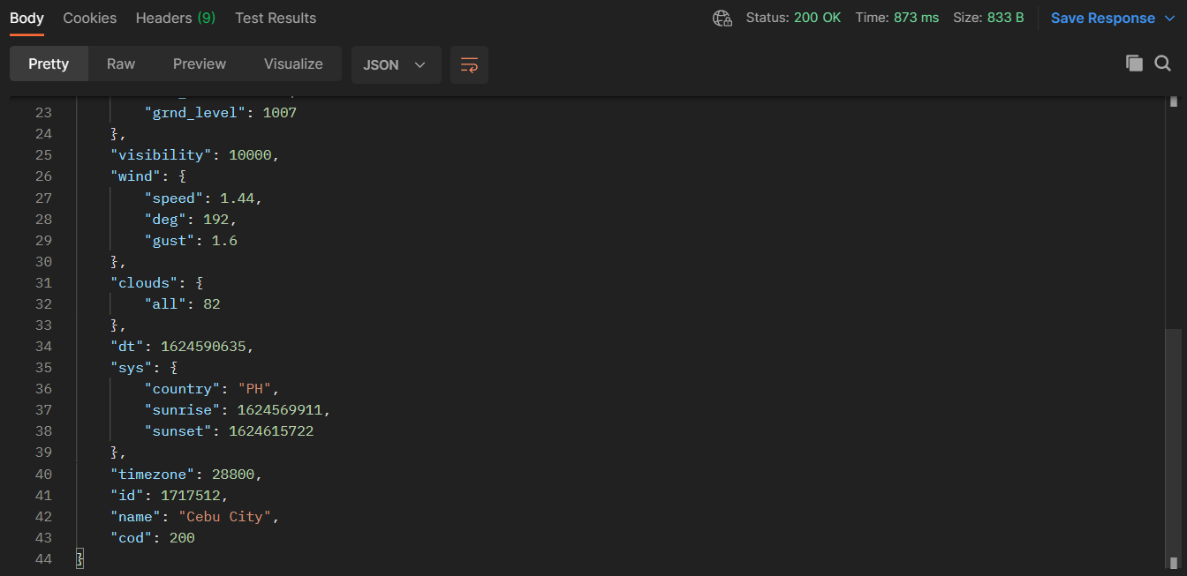

JSON (JavaScript Object Notation)
Usually the format returned or responded by the external server.

Making GET Requests with the Node HTTPS Module
- const express = require("express");
- const app = express();
- const port = 3000;

- // HTTP Request to External Server
- const https = require("https");

- app.get("/", (req, res)=> {
- const url_request = "https://api.openweathermap.org/data/2.5/weather?q=Cebu&units=metric&appid=6cd263f24d6cf07b6c85bf00ccc395c4";
- https.get(url_request, (response)=>{
- console.log(response);
- })
- res.send("Server is running.")
- });

- app.listen(port, ()=>{
- console.log("Server is running on Port " + port);
- });
- const fileSync = require("fs");
Line 06: We used the native node HTTPS module (that is installed along express) to perform a get request for Line 10.

How to Parse JSON
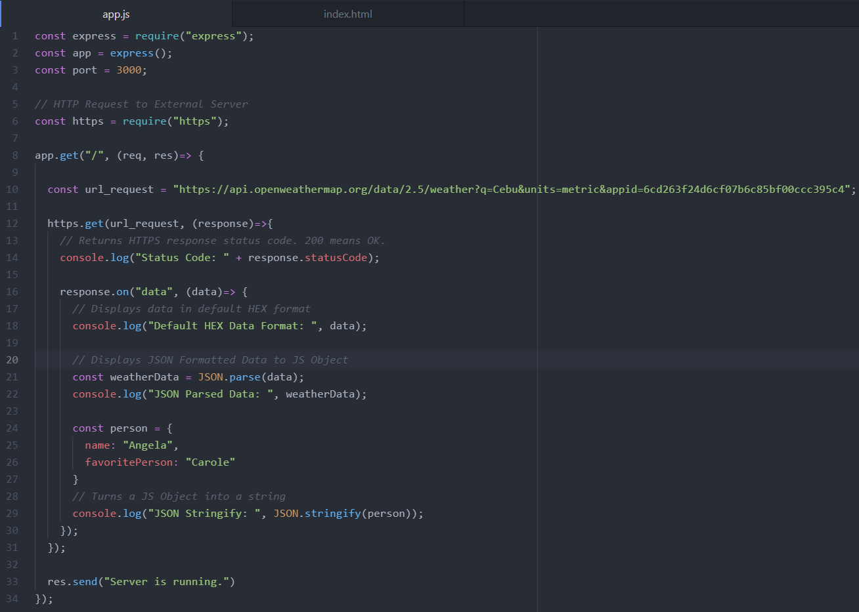
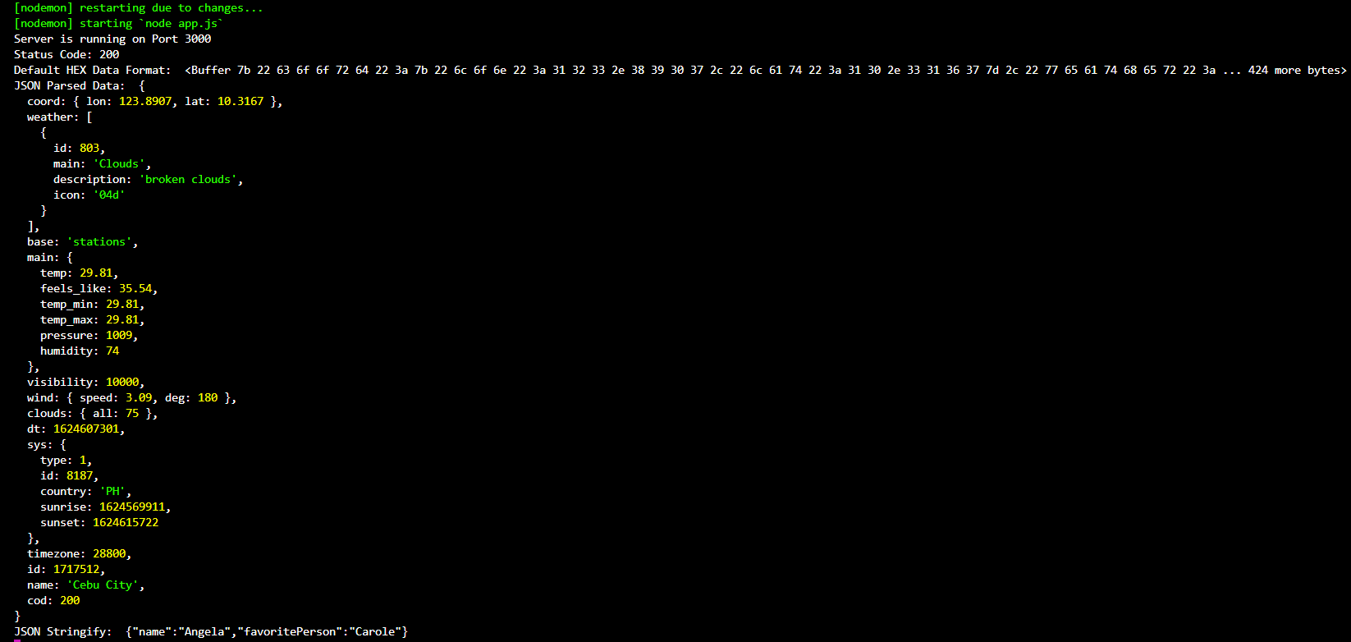

Static Files
Link: Serving static files in Express
Intro:
Creating a program with HTML, CSS, BootStrap, and images can work accordingly to your code. But when Node and Express are involved, chances are, your CSS stylesheet and Images will seem lost (or not reflected in your website).
When we take a look at our Website (xxx.html file), the BootStrap stylesheet is taken from a remote location while our custom stylesheet is taken locally since we created it. This custom stylesheet is basically a static page in our local file system that we’re trying to pull up. This scenario also applies to our images.
In order for the server to serve up static files (such as CSS, images, and JS files), then we need to use a special function of Express called: app.use(express.static(“<static_folder_name>”));

Explanation:
Static files are typically files such as scripts, CSS files, images, etc... that aren't server-generated, but must be sent to the browser when requested.
If node.js is your web server, it does not serve any static files by default, you must configure it to serve the static content you want it to serve because if you don’t, your CSS, images, or even JS files won’t be detected.
express.static() is a bit of middleware that maps directory names to the path directory for easy lookup.
public
|_ javascripts
|_ stylesheets
|_ images

Examples of loading up Static Files:
http://localhost:3000/images/kitten.jpg
http://localhost:3000/css/style.css
http://localhost:3000/javascripts/app.js
http://localhost:3000/images/bg.png
http://localhost:3000/hello.html
Note: you do not need to include the “/public” (folder where all static files are stored) when accessing the static files.

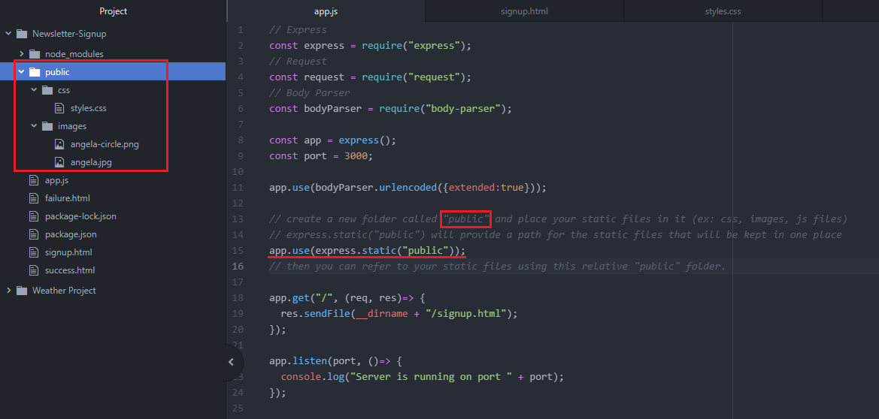
Before (HTML CSS stylesheet link):
[Folder Path]
MailChimp
|_ styles.css
|_ index.html
|_ images
|_ angela.png

[HTML]
<link href="styles.css" rel="stylesheet">
still won’t be able to load up styles.css since node.js does not serve any static files by default.

After:
[Folder Path]
MailChimp
|_ public
|_ css
|_ style.css
|_ images
|_ index.html

[.JS File]
app.use(express.static("public"));
assigned “public” folder to be the folder that contains static files for the server to load it up.

[HTML File]
<link href="css/styles.css" rel="stylesheet">
Loading up styles.css successfully.
You do not need to include the public folder in the file path
(WRONG: <link href="/public/css/styles.css" rel="stylesheet">)

POSTING DATA TO MAILCHIMPS SERVER VIA THEIR API
Homepage: https://mailchimp.com/developer/
Account Dashboard: https://us6.admin.mailchimp.com/

Account Details
Username: Eanne11
Password: alegnA11;

GENERATE API KEY
- Access your Mailchimp Account Dashboard.
- Click on your Account Logo and select Account.
- Extras tab > API Keys.
- Create a Key.
- Record the API key.
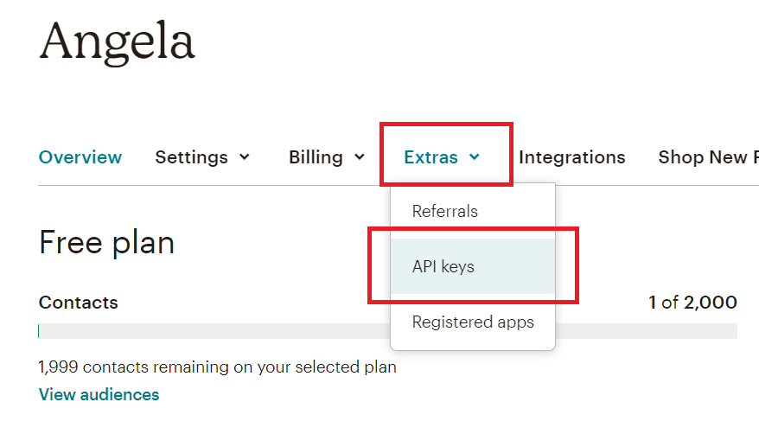
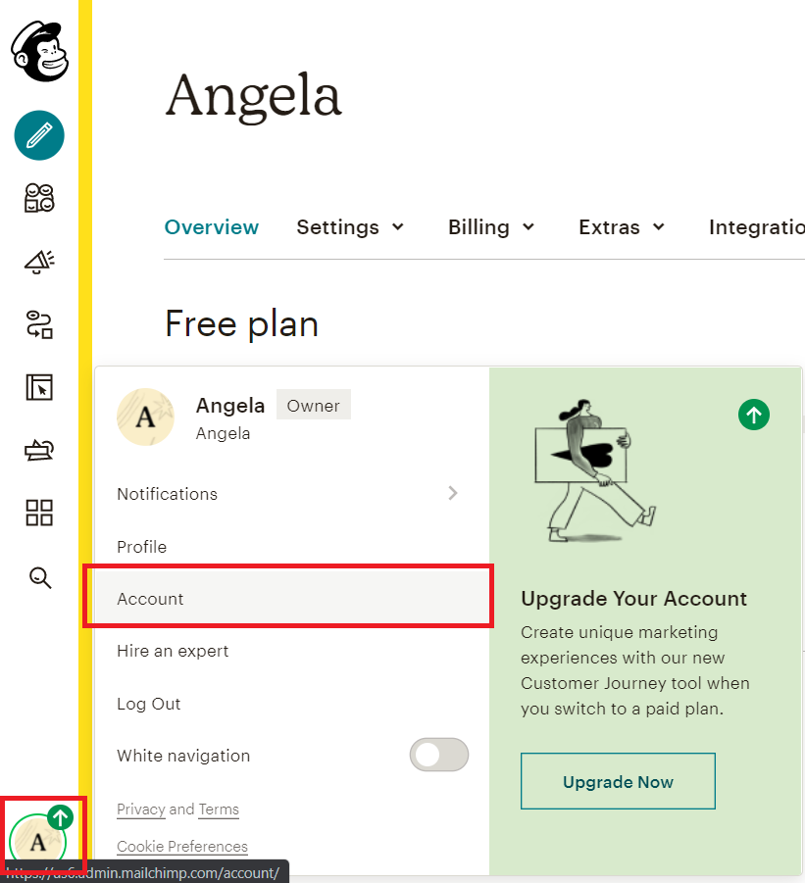

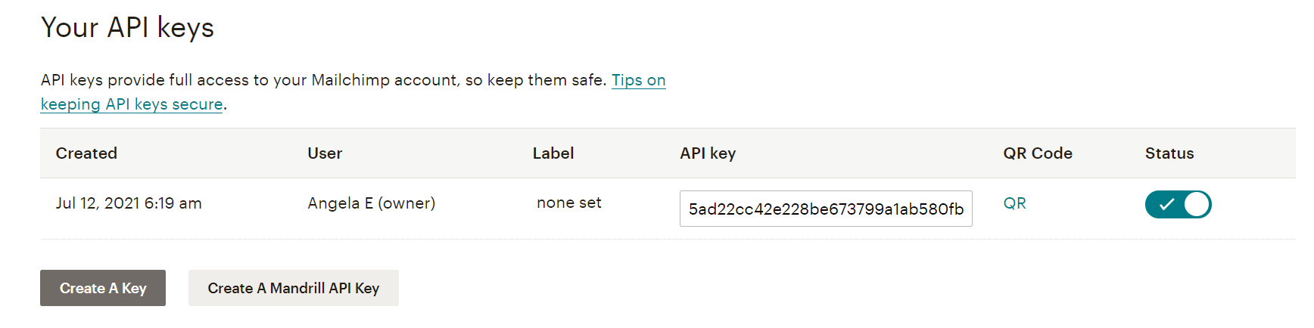

Unique ID / Audience ID / List ID
Helps MailChimp Server to identify the list that you want to put your subscribers into.
Dashboard > Audience > All Contacts > Settings: Audience Name and Defaults > Look for Audience ID.
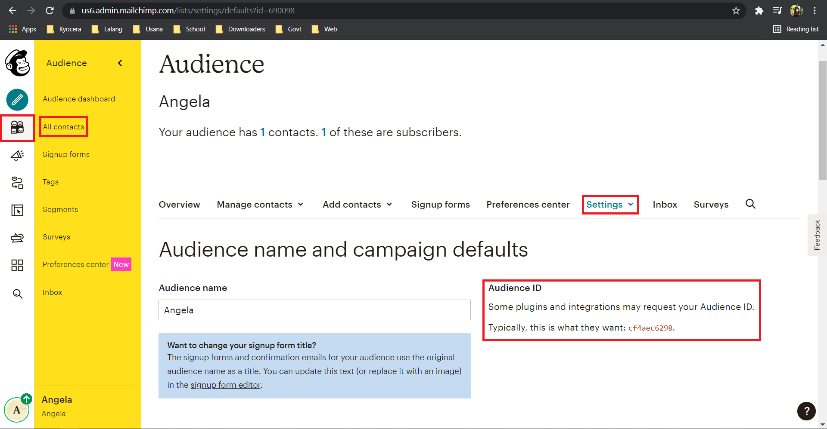

AUDIENCE FIELDS AND *|MERGE|* TAGS

